CSCV Intranet portal
Software Architecture Document
Date: | 07/02/2010
Version: | 1.0
Status: | Final
Author: | Tai Le
Reviewed by:
Approved by:

Revision History
Date | Version | Description | Author
5/25/2010 | 0.1 | Initial Draft | Tai Le
6/1/2010 | 0.2 | Update Logical View and Deployment View | Tai Le
7/3/10 | 1.0 | Final | Tai Le
1/6/11 | 1.1 | Updated | Tai Le
1/16/2012 | 1.2 | Updated Implementation Requirements | Tai Le

Table of Contents
1 Introduction 4
1.1 Purpose 4
1.2 Scope 4
2 Architectural Representation 4
3 Architectural Goals and Constraints 4
3.1 Architecturally significant requirements 4
3.1.1 Implementation Requirements 4
3.1.2 Supportability Requirements 4
3.1.3 Language 4
3.2 Technologies used 4
4 Logical & Implementation Views 5
5 Deployment View 6
6 Size and Performance 6
7 Quality 6

Introduction
The purpose of this document is to provide a high level depiction of the architecture of CSCV Intranet Portal

Purpose
This document provides a comprehensive architectural overview of the system, using a number of different architectural views to depict different aspects of the system. It is intended to capture and convey the significant architectural decisions that have been made on the system.

Scope
This document applied to the overall architecture of CSCV Intranet Portal. It does not attempt to describe the architecture of individual software components or specific modules.

Architectural Representation
To keep the document simple for training purpose, only logical view and deployment view are captured

Architectural Goals and Constraints

Architecturally significant requirements

Implementation Requirements
- CSCV Intranet Portal must be built on top of SharePoint 2010
- All features in CSCV Portal built and packaged as SharePoint feature for easier deployment to any target site
- For the Fresher Program purpose, LINQ to SharePoint is not allowed. Instead, when appropriate, use SharePoint object model and CAML queries to access data in SharePoint

Supportability Requirements
- CSCV Portal must support all enhancement functionalities as described in functional specs (slides)

Language
- CSCV Portal supports only English in user interface

Technologies used
  - SharePoint 2010
  - .NET Framework 3.5
  - JavaScript / jQuery
  - SQL 2008

Logical & Implementation Views
This section describes the architectural significant parts of the design model, such as decomposition into components.
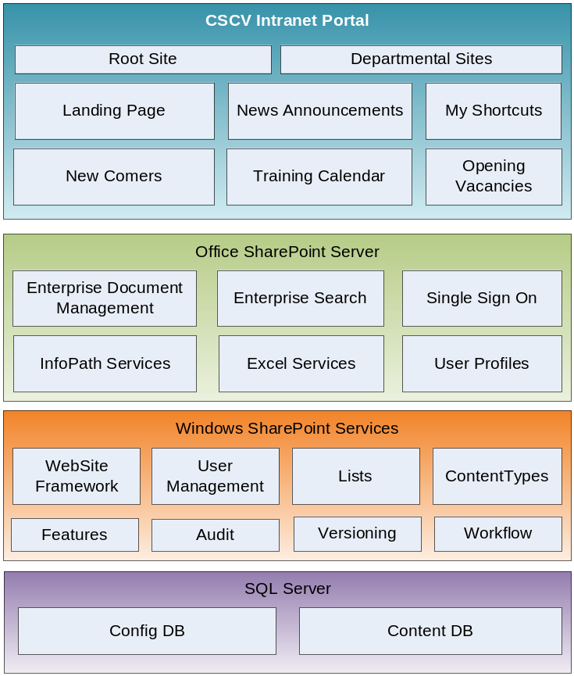
CSCV Intranet Portal is built on top of SharePoint 2010. Individual portal feature will be built as separated SharePoint feature that can be deployed and activated into any SharePoint site. Root Site is a custom site template which serves as main entry point for Intranet users; provides standard page layouts for all site content.
All site content is stored in SharePoint content Database. No external Database shall be used to store application configuration and user data. In other words, individual application in CSCV Portal will use SharePoint lists as configuration storage.
Depends on the requirement, each use case shall be implemented as SharePoint web-part, custom application page or the mix of both. All web parts must leverage MVP design pattern in its implementation. This is to help separate Business logic from User Interface logic, thus make code easier to read and maintain. Moreover, it will help maximize the amount of code that can be tested in Unit test tools such as NUnit
Package Naming convention: each solution package must follow this naming convention: CSCV.Group[Number].[Feature]

Deployment View
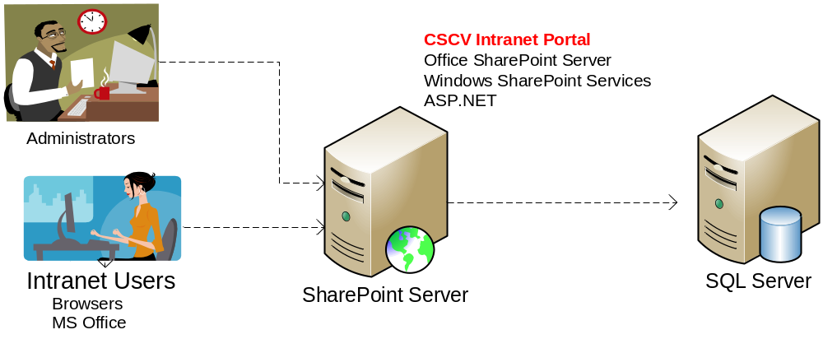A typical deployment for CSCV Intranet portal is 2-server deployment, where SharePoint and SQL are deployed on separated servers. It also has the flexibility to scale down to 1 server (all-in-one box) or scale up to multiple Web Front Ends in order to handle large user load

Size and Performance
CSCV Intranet Portal performance and scalability utilize flexibility in deployment model of SharePoint 2010

Quality
The software architecture supports the quality requirements, as stipulated in the Supplementary Specification.

